Bandelier Ecological Conservation

Mapping Invasive Species Along the Rio Grande Corridor in Bandelier National Monument

 **Technical Report**

August 11th, 2023

Evan Barrett (Project Lead)

Megan Rich

Chloe Johnson

Nusrat Zahan Jarin

***Advisors:***

Dr. Marguerite Madden, University of Georgia, Center for Geospatial Research (Science Advisor)

Joseph Spruce, Science Systems and Applications, Inc. (Science Advisor)

***Fellow:***  
Sarah Payne (Georgia – Athens)

# 1. Abstract

The Southwest U.S. has experienced a growth of invasive riparian species, specifically *Elaeagnus angustifolia* (Russian olive), *Tamarix ramosissima* (saltcedar), and *Ulmus pumila* (Siberian elm), which alter local soil chemistry and outcompete native species. Locating these exotic species is critical for ecological conservation; however, field identification can be resource intensive. NASA DEVELOP partnered with the National Park Service (NPS) at Bandelier National Monument (BAND) to assess the feasibility of using Earth observation data to map invasive species along the Rio Grande corridor of the park. The team used Landsat 8 OLI, Sentinel-2 MSI, and ISS DESIS imagery to compute principal components based on spectral bands, vegetation indices, and terrain indices. Using the first five principal components, the team created classification maps using both a k-means classification algorithm and a random forest algorithm to differentiate between native and non-native species. The team derived maps for the three invasive riparian species in the region for the last five years. The team found that invasive species covered 33% of the park's river corridor in 2023, and the invasive species extent has increased by 5.7% from 2019 to 2023. The methods will serve as a guide for aiding historic and present invasive species identification in riparian regions, and the NPS staff at BAND will use the results to inform local mitigation practices and advocate for invasive species removal.

**Key Terms**

Bandelier National Monument, remote sensing, invasive species, random forest, principal component analysis, hyperspectral

# 2. Introduction

***2.1 Background Information***

Bandelier National Monument (BAND) preserves more than 3,000 pre-Colonial archeological sites across its 34,000 acres in northern New Mexico (Figure 1; National Park Service, 2015). The park is situated upon the Valles Caldera, which formed more than one million years ago from a collapsing magma chamber, setting the foundation for a diverse ecological landscape (Jacobs et al., 2015). The land is characterized by cliffs and mesas composed of tuff, a rock formed from consolidated volcanic ash (National Park Service, 2015). The variability in topography and elevation, especially due to erosion of the tuff, supports over 700 native plant species across a diversity of habitats, including piñon-juniper woodlands, forests of ponderosa pines or mixed conifers, montane grasslands, aspen groves, and the Rio Grande and its riparian areas (Jacobs et al., 2015).

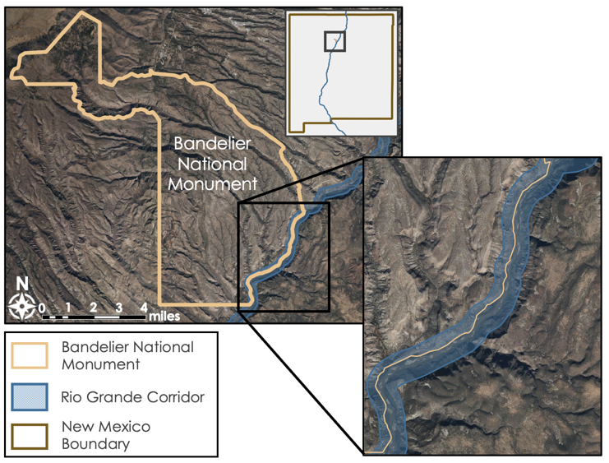

*Figure 1*. Bandelier National Monument. The study area, the park’s southwest boundary following the Rio Grande, is shown.

BAND has seen various land disturbances through the years—such as homesteading, overgrazing, and wildfires—which have introduced many non-native species to the area (National Park Service, 2015). Of all the vascular plants present in the park, over 15% were absent prior to the arrival of European settlers, and 2-3% are invasive, meaning they change the environment and drive out native species (National Park Service, 2012; Jacobs et al., 2015). In the mid-2000s, the National Park Service’s (NPS) Exotic Plant Management Team conducted invasive species control projects across multiple parks, including BAND, and implemented treatments of high priority species such as *Elaeagnus angustifolia* (Russian olive), *Tamarix ramosissima* (saltcedar), and *Ulmus pumila* (Siberian elm; National Park Service, 2006). The NPS staff removed thousands of stems of these species along the park’s Rio Grande corridor, and in the years immediately following, existing native riparian vegetation recovered greatly. However, re-establishment of these invasive tree species is a major concern for the park, and NPS staff continues to work to remove the species.

Russian olive, saltcedar, and Siberian elm are labeled as noxious weeds in New Mexico and are a significant threat to native riparian trees such as cottonwoods and willows (New Mexico Department of Agriculture, 2020). These invasives each originated in Asia and since the 1800s have become naturalized in riparian environments of the Western US after originally being planted for ornamental and landscaping purposes (Christensen, 1964; Nagler et al., 2011). Research has shown these species can spread faster than native species; for instance, studies of Siberian elm show that it germinates faster than native riparian populations (Hirsch et al., 2012). Other factors may contribute to their ability to outcompete existing plants, such as drought-tolerance, phenotypic plasticity, and speed of reseeding following wildfires (Nagler et al., 2011).

In previous remote sensing studies, researchers have been able to use classification tools to map invasive saltcedar and other species of the genus *Tamarix* in the Western US (Li et al., 2023; Bransky et al., 2021). Saltcedar and Russian olive have been mapped previously by Narumalani et al. (2009) using hyperspectral Airborne Imaging Spectroradiometer for Applications (AISA) Eagle data, and the authors described the species as “spectrally distinct.” Investigators have been able to use the increased spectral resolution of hyperspectral imagery to differentiate individual species, including the three species of interest in this study, based on unique spectral signatures (Yel & Gormus, 2023; Aneece & Thenkabail, 2021). Similar to prior researchers, the team was able to use the visual and spectral distinctions between the invasive species and the native species to classify them using a random forest approach applied to both multispectral and hyperspectral data.

The most notable prior work relating to mapping vegetation in the park took place in 2011, when BAND completed a vegetation mapping inventory project as part of the U.S. Geological Survey (USGS) Vegetation Characterization Program (Muldavin et al., 2011). This report and spatial dataset provide a comprehensive base understanding of the native and non-native fauna, including mapped occurrences of saltcedar, and may serve as a point of comparison between our results and the post-treatment land cover. To build off these previous vegetation studies of BAND, this project assessed the extent of three high priority invasive species, Russian olive, saltcedar, and Siberian elm, along the Rio Grande corridor of BAND. The team examined changes in vegetation over time using data from single-day imagery from June 2019 to June 2023.

***2.2 Project Partners & Objectives***

The DEVELOP team partnered with NPS staff at BAND to map vegetation in the park’s Rio Grande corridor using remotely sensed data to locate three high priority invasive species. Currently, park staff relies primarily on field observations to understand the extent of invasive plant species in the park. BAND resource managers require better data to identify areas where invasives can be removed. The DEVELOP team aimed to automate the process for identifying the species in the region using satellite imagery and machine learning classification techniques. Team members created vegetation classification maps and time series, showcasing the extent of invasive species in the region throughout the study period. The partners will use these end products to advocate for increased funding to aid in the removal of the invasive species and mitigation practices based on trends in the time series.

# 3. Methodology

***3.1 Data Acquisition***

The team leveraged NASA, ESA, and German Aerospace Center (DLR) Earth observation surface reflectance data alongside vector data from BAND to visualize and analyze the study area. The team acquired park boundary, roads, and trail shapefiles through the NPS Integrated Resource Management Applications (IRMA) portal. The NPS staff shared several shapefiles with the team that included vegetation polygons, areas where invasives were treated, and a 2011 parkwide vegetation inventory map with the associated report. The team utilized National Agriculture Imagery Program (NAIP) data alongside the vegetation polygons to assess and create the training points for the invasive species and other land cover classes.

Team members acquired data from Landsat 8 Operational Land Imager (OLI) and Sentinel-2 Multispectral Instrument (MSI) for multispectral analysis within Google Earth Engine (GEE). The team used Landsat 8 OLI and Sentinel-2 MSI imagery during the month of June for each year from 2019 to 2023, selecting one day in June based on temporal consistency and cloud cover. Local ecologists at BAND shared that the green-up period is the months between April and September for the species of interest, so the month of June was chosen as an optimal and consistent time to view the plants. For hyperspectral classifications, the team acquired DLR Earth Sensing Imaging Spectrometer (DESIS) data that had been atmospherically corrected. Table 1 lists all the Earth observations along with their platform, processing level, resolution, and temporal information.

*Table 1.* Earth observations processed in this study

|  |  |  |  |  |
| --- | --- | --- | --- | --- |
| **Platform & Sensor** | **Product and Processing Level** | **Spatial and Temporal Resolution** | **Imagery Used** | **Data Provider** |
| Landsat 8 OLI | Level 2 Collection 2 Tier 1 Surface Reflectance  (LANDSAT/LC08/C02/T1_L2) | 30m, 16-day revisit | June 15, 2022 | United States Geological Survey (USGS), NASA |
| Sentinel-2 MSI | Harmonized Level 2A Surface Reflectance  (COPERNICUS/S2_SR_HARMONIZED) | 10m, ~5-day revisit | June 2019-2023 | European Space Agency (ESA) Copernicus Open Access Hub |
| ISS DESIS | Level 2A (Surface Reflectance) | 30m, no repeat orbital cycle | June 15, 2022 | German Space Agency, Data acquired from Teledynamics, Commercial Smallsat Data Acquisition (NASA) |

***3.2 Data Processing***

*3.2.1 Training Points*

The team remotely created training data through manual identification by referencing partner-provided vegetation data. The park staff provided shapefiles that consisted of polygon locations of species within BAND and other regional parks treated by the region’s Invasive Plant Management Team. DEVELOP team members utilized points from the partner-provided data and Vorster et al. (2018), which were mostly geographically distant, as visual references. The team used 1-meter spatial resolution NAIP imagery from May 2022 viewed in GEE to manually create points for running a supervised classification. The team created points for the following classes: water, bare soil, upland vegetation, Russian olive, saltcedar, Siberian elm, native riparian vegetation, and cottonwood trees. For the collected training points from 2022, each of these classes contained at least 30 points, except for Siberian elm which had 16 points due to the limited confidence of the identification of these trees within the study area (Table A1).

The team selected classes based on the predominant land cover types within BAND and its riparian areas. The water class primarily encompasses the river, while the bare soil and upland vegetation classes are not near to the river but were necessary for a more complete classification. The upland vegetation class, which is also referred to as grasses and shrubs, includes all non-riverine vegetation. Most training points for this class align with juniper bushes, which can be found along mesas. Because the training data did not include tall upland trees such as Ponderosa pines, these trees often fall within the upland vegetation class in the results. The three target invasive species each constitute their own class. The Vorster et al. (2018) dataset contained points of Russian olive, tamarisk, and cottonwood trees in New Mexico and neighboring states; however, reference material for Siberian elm was scarce and the tree is less visually distinct in satellite imagery than the other two invasives. For these reasons, the team relied on information from partners to select fewer areas of high confidence for Siberian elm as compared to Russian olive and saltcedar. Cottonwood, as mentioned previously, had reference data for selecting training points and is also one of the most common riparian trees in the study area, with few to no other native species reaching a similar height. The team decided to make cottonwood trees a class of its own due to this confidence level in the identification. Native riparian vegetation, at times labeled simply as riparian, encompasses all the native vegetation that does not fit within the other four riparian classes. The team selected the points for this class by identifying herbaceous or shrub-like native plants, which primarily consisted of willows.

*3.2.2 Multispectral Imagery Pre-processing*

The team used GEE to process Landsat 8 OLI and Sentinel-2 MSI imagery. Team members filtered the imagery based on the study period and region of interest before applying a cloud filter of 75% and cloud mask to produce cloud-free imagery. For the Landsat 8 OLI cloud mask for, the team used the pixel quality assessment (QA) band to remove pixels associated with clouds, including cloud shadows. For the Sentinel-2 MSI cloud mask, the team acquired the European Space Agency (ESA) Sentinel-2 Cloud Probability image collection and masked out images that had at least 75% probability of pixels associated with clouds. The Sentinel-2 Cloud Probability collection was used due to its high resolution of 10 meter compared to the QA60 band with a 60-meter resolution. Team members selected June images within each image collection with the least amount of cloud cover as the image to classify. To utilize the Landsat 8 data, the team applied the standard scale factor of 0.0000275 and then added -0.2 in accordance with the USGS documentation.

*3.2.3 Pansharpening DESIS Imagery*

The team acquired hyperspectral DESIS imagery which possesses 235 spectral bands ranging from visible (400nm) to near infrared (1000nm) wavelengths but has a medium spatial resolution of 30m. To get more detailed visual clarity while preserving spectral quality, the team utilized the Gram-Schmidt Pan Sharpening method in ENVI using 10m-spatial resolution data from Sentinel-2 MSI (Maurer, 2013). Due to the lack of a panchromatic band in Sentinel-2 MSI, team members calculated a Panchromatic-like band by averaging the values of Sentinel-2 MSI’s four 10m bands, which cover the spectral range of DESIS: Red, Blue, Green, and Near Infrared (NIR). The team tested the quality of the pansharpened image by comparing the average spectral values and resulting imagery of the original DESIS image with the pansharpened image (Figure 2).

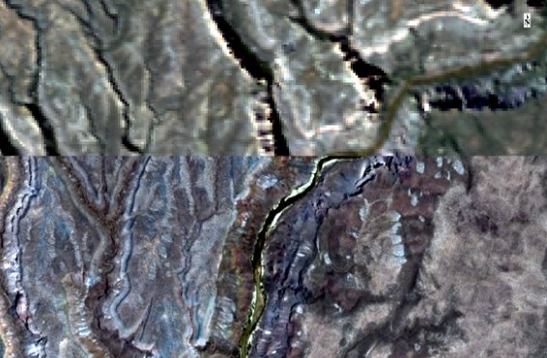

Figure 2. Original DESIS imagery of the Rio Grande with 30m spatial resolution (top) and DESIS data after being pansharpened with 10m Sentinel-2 data (bottom). © Teledyne Brown Engineering, Inc., 2022. All Rights Reserved. Includes copyrighted material of Teledyne Brown Engineering, Inc., All Rights Reserved.

*3.2.4 Spectral Indices and Principal Component Analysis*

The team calculated several spectral indices from Landsat 8 OLI and Sentinel-2 MSI imagery in GEE, which included the Normalized Difference Vegetation Index (NDVI), Normalized Difference Moisture Index (NDMI), Enhanced Vegetation Index (EVI), Modified Soil Adjusted Vegetation Index (MSAVI2), Leaf Area Index (LAI), and Tasseled Cap Brightness (TCB), Wetness (TCW), and Greenness Index (TCG). The team also included Height Above Nearest Drainage (HAND) to introduce a normalized drainage and terrain factor in the analysis. Due to high correlation between indices, the team conducted a principal component analysis (PCA) using all available spectral bands and the spectral indices for Landsat 8 OLI and Sentinel-2 MSI data (Table A2; Table A3). PCA converts correlated variables to uncorrelated components, simplifying the complexity of high-volume datasets (Jolliffe, 2002). Team members computed percent variance in the data as explained by each principal component and used enough resulting components to cover at least 95% of the original variance in the data. This reduced the number of Sentinel-2 MSI and Landsat 8 OLI variables from 18 and 15, respectively, to 5 (Figure A1).

The team utilized two methods for dimensional reduction when processing the DESIS data. Initially, team members reduced the number of spectral bands from 235 to 29 based on a study by Aneece and Thenkabail (2021), which identified the 29 bands as optimal for crop identification studies based on a lambda-by-lambda correlation analysis. Additionally, team members performed a PCA on the DESIS data with the original 235 spectral bands as well as calculated NDVI, MSAVI2, EVI, and LAI using chosen red (640 nm), green (550 nm), blue (470 nm), and NIR (1000 nm) bands to reduce the number of inputs from 235 spectral bands and 4 vegetation indices to 5 principal components. The team could not calculate Tasseled Cap indices or NDMI due to the lack of bands in the shortwave infrared (SWIR) range of light.

***3.3 Data Analysis***

*3.3.1 Unsupervised Vegetation Classification*

As the training data consisted of visually inspected point data rather than field data, the team conducted an unsupervised vegetation classification of 2022 imagery to evaluate the potential of classifying the riparian vegetation without the use of training data. The team performed a k-means unsupervised classification on June 15, 2022 Landsat 8 OLI, Sentinel-2 MSI, and pansharpened DESIS imagery using the first five principal component bands obtained from each respective PCA (Figure A1). The k-means classifier uses machine learning algorithms in GEE and ENVI to find spectral patterns and determine k distinct groupings for the pixels in the study region (MacQueen, 1967). The team chose to group the pixels into 8 clusters based on the 8 classes of interest. After running the classifier, the team overlayed the training data on the resultant image to evaluate which cluster was associated with each class.

*3.3.2 Supervised Random Forest Classification and Cross-Sensor Agreement*

To classify the land cover types in the study area from 2019 through 2023, the team applied a 175-tree random forest algorithm, which relies on training data and multiple decision trees to classify each pixel in a region (Breiman, 2001). Team members used training points made from May 2022 NAIP data observations to train the classifier and produce land cover maps of Landsat 8 OLI, pansharpened DESIS, and Sentinel-2 MSI imagery using the first five principal components from each respective PCA. For the pansharpened DESIS classification, team members also utilized the 29-band imagery and the full 235 band imagery. The team used 70% of the training data for classification and reserved 30% for testing if the classification was accurate via a confusion matrix. Team members derived 70% of points to use for training by splitting the entire dataset at once, resulting in some classes having more or less than 70% and 30% of their individual points in the training set and validation set, respectively.

The classifications of each sensor used imagery dated from June 15; for Landsat 8 OLI and DESIS, this was only for the year 2022, while the Sentinel-2 MSI imagery was classified from the years 2019-2023, also using a day within a week of June 15 of each year. The team classified Sentinel-2 MSI imagery over a range of years because it had both better spatial resolution at 10 meters and had available data for the last five years, which was necessary for producing the time series.

Using the supervised classifications derived from June 15, 2022 Sentinel-2 MSI, Landsat 8 OLI, and pansharpened DESIS imagery, the team calculated the pixels where multiple sensors agreed on the classification of that pixel using the Raster Calculator tool in QGIS. Specifically, the team focused on pixels of agreement for the three invasive species of interest: Russian olive, saltcedar, and Siberian elm. The team identified pixels of agreement between all three sensors as well as between only the Sentinel-2 MSI and the pansharpened DESIS imagery to compare the two 10m spatial resolution classifications.

*3.3.3* *Spectral Angle Mapping*

To isolate pixels with similar spectral signatures to the invasive species of interest, the team created a spectral library for the 8 distinct classes using the May 2022 NAIP training points and June 15, 2022 DESIS imagery. Team members sampled both the original 30m spatial resolution and the pansharpened 10m spatial resolution imagery to observe how the results vary with different spatial resolutions. The team used the average spectral signature associated with each class to create a reference library and then applied a spectral angle mapper (SAM) classification algorithm in ENVI, which looks at the spectra of each individual pixel in a region and assigns it a classification based on which spectral signature in the reference library matches it the most.

*3.3.4 Historic Extent, Change Detection, and River Profile*

The team investigated vegetation changes along the park’s Rio Grande corridor from one day in the week of June 15 of each year for 2019 to 2023. The team was limited to this study period due to a lack of Sentinel-2 MSI imagery for years outside of 2019-2023 in the region. Due to its high spatial, medium spectral resolution, and available imagery for each June, the team relied solely on classified Sentinel-2 MSI imagery to observe changes over the study period. Team members calculated the number of pixels within each class of the classified images using the Raster Layer Unique Values Report tool in QGIS. In addition to looking at each year individually, the team utilized supervised classifications derived from June 15, 2019 and June 15, 2023 Sentinel-2 MSI imagery to observe where invasive species have overtaken native species. Specifically, team members looked at pixels in the Rio Grande corridor that were classified as either cottonwood or native riparian species based on 2019 imagery and classified as one of the invasive species based on 2023 imagery.

To analyze how each of the species of interest varied depending on downstream distance, the team used a shapefile that buffered the river by 200 meters to encompass the riparian study area. Team members split the approximately five-mile portion of the Rio Grande into ten equal area sections using the “Subdivide Polygon” tool in ArcGIS Pro. The team tabulated areas of the classified raster within the study area polygon, which produced sum totals of each class type within all ten half-mile sections. The team observed tables of the areas in square meters for all five years and interpreted the data in a series of graphs.

# 4. Results & Discussion

***4.1 Analysis of Results***

*4.1.1 Unsupervised Classification Maps*

To assess the output of the k-means clustering algorithm, the team first looked to assign each of the generated clusters to a land cover class. After overlaying the Sentinel-2 unsupervised classified map over high-resolution NAIP imagery, team members found that the lack of spectral variance within the park’s boundary impaired the algorithm’s ability to extract distinct classes along the Rio Grande corridor. The classification map captured variance between the riparian vegetation and upland vegetation; however, it did not provide insight into the differences within the riparian zone (Figure 3). To try to reduce the amount of spectral variance, team members attempted the k-means classifier on only the riparian area rather than the whole park, but the algorithm was still unable to reliably differentiate between the species of interest upon visual inspection. No classes were assigned to the unsupervised classification map and no uncertainty analyses were conducted due to a lack of correspondence between the output and the classes of interest.

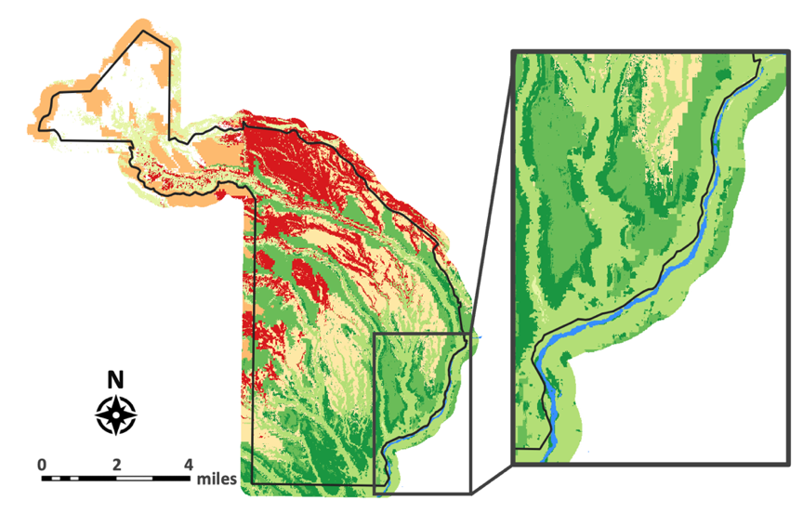

Figure 3. K-means unsupervised classification map of BAND and surrounding area derived from June 15, 2022 Sentinel-2 MSI imagery. The Rio Grande corridor of BAND, shown in blue, is inset on the right. The lack of a legend is because no classes were assigned for the analysis.

*4.1.2 Supervised Classification Maps*

The random forest algorithm was able to differentiate between the riparian species more effectively than the k-means cluster algorithm. The random forest classifications varied based on the spatial and spectral resolution of the sensor: the most accurate sensor was Sentinel-2 MSI, with 62% overall accuracy and a kappa coefficient of 0.55 in 2022 (Table C1). Landsat 8 OLI had an overall accuracy of 52% with a kappa coefficient of 0.44, likely lower than Sentinel-2 MSI due to the lower resolution of Landsat 8 OLI (Table C2). Both classifications were able to restrict the vegetation classes—both invasive and native—to the riparian region, and the classifier trained with Sentinel-2 MSI imagery was better able to differentiate the vegetation from the river and the surrounding grasses and shrubs compared to that derived from Landsat 8 OLI imagery (Figure 4; Table C1; Table C2).

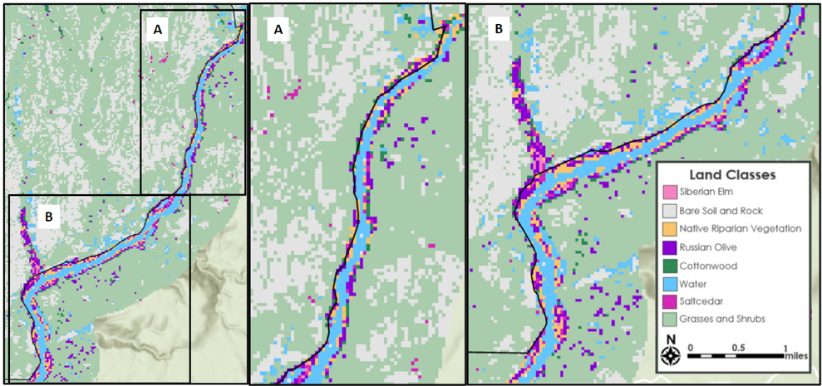

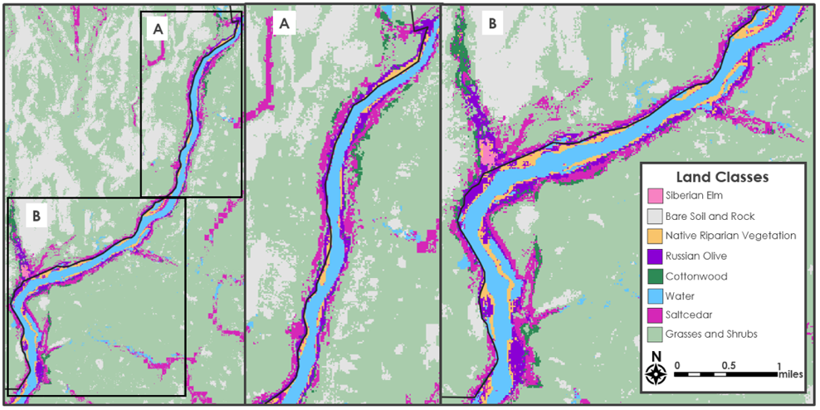

*Figure 4.*  Random forest supervised classification of the Rio Grande corridor of BAND derived from June 15, 2022, Landsat 8 OLI (top) over a topographic basemap and June 15, 2022, Sentinel-2 MSI (bottom) imagery.

In addition to analyzing the multispectral data, team members conducted random forest classifications on the pansharpened June 15, 2022, DESIS imagery with the whole wavelength spectra (n=235), the optimal vegetation identification bands (n=29), and the principal components (n=5) as inputs (Figure 5). The team was unable to incorporate all the training data points into the analysis because only a subset of points (n=330) was located inside of the available DESIS imagery. The random forest classifier was able to classify the pansharpened DESIS imagery with greater than 90% overall agreement with the validation set, with the classifier trained on the 5 principal components producing the highest agreement with 98.17% (Figure 5; Table C3; Table C4).

*Figure 5.*  Random forest land cover classification of pansharpened June 15, 2022 DESIS imagery of the Rio Grande corridor of BAND using 5 principal components as inputs.

The cross-sensor agreement analysis found 10m resolution pixels of agreement across the whole study area (Figure B1). The analysis showed that 4151 pixels–12.5% of the study area–were classified as one of the three invasive species using the Sentinel-2 MSI and pansharpened DESIS imagery, whereas only 1606 pixels—4.84% of the study area—were classified as invasive by all three sensors. The lower amount of agreement when considering all three sensors is likely due to the coarse resolution of the Landsat 8 OLI imagery in comparison to the Sentinel-2 MSI and pansharpened DESIS imagery. When looking at the individual species, the team found that the Russian olive class had the most points of agreement, with 48.39% of the 4600 pixels classified as Russian olive with pansharpened DESIS imagery also being classified as Russian olive with Sentinel-2 MSI imagery.

*4.1.3 Spectral Angle Mapper Classification*

The team utilized the 235 band DESIS imagery for further analysis to differentiate the different types of riparian vegetation in the study region. The spectral signatures of the three invasive species were relatively distinct from each other based on the values extracted from the training points; however, certain classes—such as Russian olive and cottonwood—had similar spectra that made it difficult to differentiate between the two classes (Figure B2). Other classes, such as water and Siberian elm, had relatively unique spectra, increasing confidence in the classifications of those classes.

The overall accuracy and kappa coefficient of the spectral angle mapper classification varied based on the pre-processing of the DESIS imagery. The original, 30m resolution DESIS imagery resulted in an overall accuracy of 40.37% and a kappa coefficient of 0.33, while the pansharpened DESIS imagery had a validation agreement of 44.95% and a kappa coefficient of 0.38 (Table C5). Both kappa coefficients are greater than 0, indicating that the SAM classifier was more accurate than a random assessment of the pixels. The increase in overall accuracy with the pansharpened imagery is likely due to the increase in resolution which allows for individual vegetation classes to stand out from their surrounding classes. The confusion matrix derived from the accuracy assessment of the 30m DESIS imagery indicates that 9 vegetation points were mistakenly classified as water, whereas the confusion matrix of the pansharpened images indicates that only 2 vegetation points were classified as water (Table C6; Table C7). The coarse, 30m resolution of the DESIS imagery likely results in large amounts of spectral mixing in the riparian areas, making it harder to distinguish between water and the adjacent vegetation. Thus, in this case, the finer resolution imagery has an advantage because of a reduced amount of spectral mixing. However, the SAM classifications had lower overall agreements, likely because the reference spectra were not pure but rather an average of several pixels of reference for each class.

*4.1.4 Historic Extent, Change Detection, and River Profile*

Across the study region, there was an overall increase of 5.7% in the area of invasives from 2019 to 2023, which equates to 15.57 acres of invasive coverage (Table B1). The team observed changes from native to invasive species in the whole Rio Grande corridor of the park, with a majority being in the southern half (Figure 6). The team found that 42.81% of the native vegetation and cottonwood pixels in 2019 changed to one of the invasive species in 2023. The majority (62.72%) of that change was from native riparian vegetation to Russian olive (Figure 6; Table B2), and the smallest change (0.46%) was cottonwood to Siberian elm (Figure 6; Table B2).

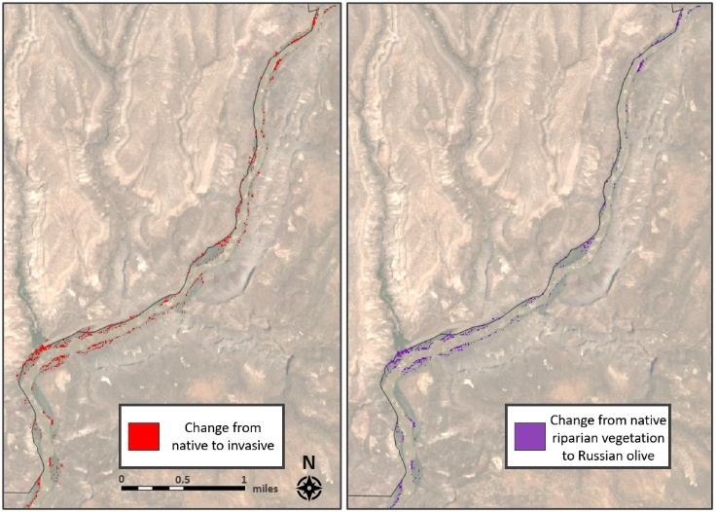

*Figure 6*. A map of the BAND Rio Grande corridor with red pixels showing pixels that were classified as native cottonwood or native riparian vegetation in 2019 and classified as invasive in 2023 (left) and a map with purple pixels showing pixels that were classified as native vegetation classes in 2019 and Russian olive in 2023 (right).

Includes copyrighted material of Teledyne Brown Engineering, Inc., All Rights Reserved.

The team found that saltcedar is predominantly located in the northern stretch of the river, while Russian olive and Siberian elm are common along the southern stretch (Figure 7; Figure B3; Figure B4). For each invasive species, the team found that they appear most frequently at the intersections of the river corridor and the canyons (Figure 7; Figure B3; Figure B4).

*Figure 7.*  River transect graph displaying the change in Russian olive coverage at half-mile intervals alongside the portion of the Rio Grande following BAND’s border.

***4.2 Feasibility Assessment***

This project successfully showed the effectiveness of using Earth observation data for mapping invasive vegetation at a species level, especially when utilizing the increased spectral resolution of hyperspectral imagery. The ability to map vegetation remotely is considerably useful for the partners as it allows the park to visualize invasive species growth over time. Mapping vegetation remotely using readily available Earth observation data is a cost-effective and time-saving alternative to field investigations, which may require approved funding and a significant time investment. The partners may not have the technical capacity to implement the methods to run the analyses described in the project due to a lack of coding experience; however, they will use and adapt the end products and data to advocate for funding to aid in curbing invasive spread.

***4.3 Future Work***

The study and its methodology can be improved upon for future vegetation and land cover mapping efforts. To improve the random forest classification and increase its reliability, surveyors and field researchers should collect field training points of the species of interest and other land cover classes. In situ training points would provide more data to train the classifier while also allowing for increased validation assessments. Additionally, researchers could collect in situ spectra of each of the respective classes of interest to establish a spectral library rather than relying on remotely observed points for hyperspectral classification. Future investigators should also train data using multiple data within a year or within a season to account for phenological changes amongst the species and utilize those differences in the classification algorithm.

The partners can use the produced maps and data outputs to continue to monitor the locations of invasive species within BAND. Park staff will visit the areas of invasion and assess the overall accuracy of the classifications. Additionally, partners can use the methodology in the future to classify up-to-date satellite imagery to continuously monitor the whole Rio Grande corridor in real time without having to go out into the field. In doing so, the park staff can better advocate for funding and other resources necessary for the removal of these species from BAND.

# 5. Conclusions

This research utilizes both multispectral and hyperspectral data to identify areas of invasive species within a riparian region. The team was able to produce vegetation classification maps based on remotely-collected training points with overall agreements varying based on the sensor—especially in the case of the hyperspectral data having a comparatively high overall agreement of 98%—and the processing methodology used. Across all three sensors, principal components derived from spectral bands, vegetation indices, and terrain indices increased the overall agreement of the classifications while also reducing the number of inputs. The team found that hyperspectral data was more effective at differentiating individual vegetation species when compared to multispectral data. The increased number of bands in hyperspectral data allows the random forest classifier to identify species based on small spectral differences that are not visible when looking at multispectral signatures.

The team found that the invasive species of the park were largely concentrated around areas where canyons intersect the Rio Grande corridor, and that the spatial distribution of the invasives varies by species. Russian olive and Siberian elm trees peaked in southern regions of the park near Alamo Canyon, whereas saltcedar peaked in the northern regions of the river corridor around Frijoles canyon. Furthermore, team members calculated that the amount of invasives in the park had increased between 2019 and 2023, and that this increase correlated with a decrease in the amount of land classified as native vegetation. Across the whole study area, 42.81% of the pixels classified as native vegetation classes from 2019 imagery were classified as invasive classes in 2023, indicating a community-level shift in the vegetation in these regions or a change in the environment that may indicate of the presence of invasive species.

Supervised classifications can effectively be used to monitor invasive species and will be useful for future decision-making processes. Project partners at BAND and the NPS will use the vegetation maps to locate these species of interest and properly remove them as part of their vegetation management plans. Furthermore, partners can use trends identified in the time series, change detection, and river transect analyses to mitigate the effects of the invasive species by predicting where they will continue to spread. Park staff and future researchers can build upon the methodology and results of this study by incorporating additional field data for training and validation. These mitigation and treatment practices will help protect the native species from the spread of invasives while also protecting the soil, watershed, and communities that depend on those local resources.

# 6. Acknowledgements

This team would like to thank our partners from Bandelier National Monument and the NPS: Sarah Milligan, Anna Wheeler, Kay Beeley, Priscilla Hare, Laura Trader, and Cassandra Suddath. The partners provided datasets and input that made this project possible, and they also helped team members communicate the findings of the project. The team would also like to thank Sarah Payne for proposing and guiding the project as well as Dr. Marguerite Madden and Joseph Spruce for their scientific advising and overall support. Lastly, the team thanks the Summer 2023 Paria River Ecological Conservation and Capitol Reef Ecological Conservation DEVELOP teams for their input and collaboration.

This material contains modified Copernicus Sentinel data (2019-2023), processed by ESA.

This work utilized data made available through the NASA Commercial Smallsat Data Acquisition (CSDA) program. © Teledyne Brown Engineering, Inc., 2022. All Rights Reserved. Includes copyrighted material of Teledyne Brown Engineering, Inc., All Rights Reserved.

Any opinions, findings, and conclusions or recommendations expressed in this material are those of the author(s) and do not necessarily reflect the views of the National Aeronautics and Space Administration. This material is based upon work supported by NASA through contract NNL16AA05C.

# 

# 7. Glossary

**Bands –** Layers in a raster dataset representing a single matrix of cell values, often in the form of a range on the electromagnetic spectrum, such as the color bands red, blue, and green.

**Confusion matrix –** Visual representation of the difference between the actual and predicted classifications of a model. It is used to easily recognize how often a classification system mislabels one classification as another.

**DESIS –** DLR Earth Sensing Imaging Spectrometer; a hyperspectral Earth observation satellite mounted on the International Space Station (ISS).

**ENVI –** A geospatial imagery analysis software capable of analyzing multispectral and hyperspectral data.

**EVI –** Enhanced Vegetation Index, used to quantify vegetation greenness. However, EVI corrects for some atmospheric conditions and canopy background noise and is more sensitive in areas with dense vegetation.

**Google Earth Engine** – A cloud-based geospatial imagery viewer and data processing platform that is run using the JavaScript programming language.

**HAND-** Height Above the Nearest Drainage; a drainage normalizing terrain index.

**Hyperspectral imaging –** A technique that collects data with high spectral resolution (widely across the electromagnetic spectrum) and typically has low spatial resolution.

**Invasive species –** Non-native, exotic, alien, or non-indigenous species that are or have the potential to become successfully established or naturalized and spread into new localized natural habitats or ecoregions with the potential to cause economic or environmental harm.

**Earth observations** **–** Satellites and sensors that collect information about the Earth’s physical, chemical, and biological systems over space and time.

**K-means Clustering Algorithm –** An unsupervised classification method that makes inferences from a dataset and groups objects into clusters based on similarities of characteristics.

**Landsat** **–** A joint NASA/USGS program that is the longest running enterprise for acquisition of satellite imagery from Earth.

**LAI –** Leaf Area Index; Quantifies the amount of leaf area per unit ground area. It also is expressed as net primary production.

**Multispectral –** imagery captured within specific wavelength ranges across the EM spectrum, usually up to six spectral bands between visual and near-infrared.

**MSAVI2 –** Modified Soil Adjusted Vegetation Index; designed to minimize the soil brightness effect in areas of low vegetation.

**Native plant –** Native plants have formed symbiotic relationships with native wildlife over thousands of years, and therefore, offer the most sustainable habitat.

**NDVI –** Normalized Difference Vegetation Index; a spectral vegetation index using near infrared and shortwave infrared wavelengths to estimate vegetation health.

**NDMI –** Normalized Difference Moisture Index; a spectral moisture index that detects moisture level in vegetation using a combination of near infrared and short-wave infrared spectral bands.

**Pansharpening –** The process of merging a high-resolution panchromatic image or raster band with a lower-resolution multi-band raster to increase the spatial resolution of the multiband image.

**Principal Component Analysis –** A statistical procedure that allows you to summarize informational content in large data tables by means of a smaller set of “summary indices” that can be more easily visualized and analyzed.

**Random Forest –** The random forest algorithm is made up of a collection of decision trees, and each tree in the ensemble is comprised of a data sample drawn from a training set with replacement.

**Riparian zone –** Lands that occur along the edges of rivers, streams, or other water bodies and the associated plant habitats and communities.

**Sentinel –** An Earth observation mission from the Copernicus Programme of the European Space Agency (ESA) that acquires high spatial resolution imagery over land and coastal waters.

**Supervised classification –** An image processing technique to classify pixels by relying on user-selected training sites or input classes.

**Time series –** A collection of observations of well-defined data items obtained through repeated measurements over time.

**TCB –** Tasseled Cap Brightness; Measured value for variations in soil background reflectance.

**TCG** **–** Tasseled Cap Greenness; Measured value of the greenness of the vegetation

**TCW** **–** Tasseled Cap Wetness; Measured value for interaction of soil and vegetation moisture

**Unsupervised classification** **–** A machine learning algorithm that groups pixels with common characteristics based on software analysis of images rather than user-provided sample classes.

**Vegetation Indices –** A tool that allows the calculation of a statistic using spectral reflectance data that conveys information about an area’s vegetation.

**River Transect –** A graph showing the river profile, extent, and characteristics.

# 8. References

Aneece, I., & Thenkabail, P. S. (2021). Classifying crop types using two generations of hyperspectral sensors

(Hyperion and DESIS) with machine learning on the cloud. *Remote Sensing*, 13(22), 4704. MDPI AG. <http://dx.doi.org/10.3390/rs13224704>

Baig, M. H. A., Zhang, L., Shuai, T., & Tong, Q. (2014). Derivation of a tasselled cap transformation based on Landsat 8 at-satellite reflectance. *Remote Sensing Letters,* 5(5), 423–431. <https://doi.org/10.1080/2150704X.2014.915434>

Bransky, N., Sankey, T., B. Sankey, J., Johnson, M., & Jamison, L. (2021). Monitoring *Tamarix* changes using WorldView-2 satellite imagery in Grand Canyon National Park, Arizona. *Remote Sensing,* 13(5), 958–974. <https://doi.org/10.3390/rs13050958.>

Breiman, L. (2001) Random forests. *Machine Learning*, 45, 5–3. <http://dx.doi.org/10.1023/A:1010933404324>

Christensen, E. M. (1964). The recent naturalization of Siberian elm (*Ulmus pumila L.*) in Utah. *Great Basin Naturalist,* 24(3/4), 103–106. <https://www.jstor.org/stable/41711107>.

Copernicus Sentinel-2 (processed by ESA), (2021). *MSI Level-2A BOA Reflectance Product*. Collection 1. European Space Agency. [https://doi.org/10.5270/S2-znk9xsj](https://doi.org/10.5270/S2_-znk9xsj)

Gao, B. (1996). NDWI—A normalized difference water index for remote sensing of vegetation liquid water from space. *Remote Sensing of Environment*, 58(3), 257–266. <https://doi.org/10.1016/S0034-4257(96)00067-3>

German Aerospace Center (DLR) (2019): DESIS-Hyperspectral Images - Global.

<https://doi.org/10.15489/hxom21uqeo90>

Hirsch, H., Wypior, C., von Wehrden, H., Wesche, K., Renison, D., & Hensen, I. (2012). Germination performance of native and non-native *Ulmus pumila* populations. *NeoBiota*, 15*,* 53–68. <https://doi.org/10.3897/neobiota.15.4057>

Huete, A., Justice, C., & Van Leeuwen, W. (1999). MODIS vegetation index (MOD13) algorithm theoretical basis document. <https://www.cen.uni-hamburg.de/en/icdc/data/land/docs-land/modis-collection6-vegetation-index-atbd-mod13-v03-1.pdf>

Iio, A., Hikosaka, K., Anten, N. P., Nakagawa, Y., & Ito, A. (2014). Global dependence of field‐observed leaf area index in woody species on climate: a systematic review. *Global Ecology and Biogeography*, 23(3), 274–285. <https://doi.org/10.1111/geb.12133>

Jacobs, B., Judy, B., Fettig, S., Beeley, K., Haffey, C., Schwemm, C., Palumbo, J., & Thomas, L. (2015). Bandelier National Monument Natural Resource Condition Assessment, Natural Resource Report NPS/BAND/NRR—2015/1000. National Park Service, Fort Collins, Colorado. <http://npshistory.com/publications/band/nrr-2015-1000.pdf>

Jolliffe, I. (2002). Principal Component Analysis. 2nd Edition, Springer, New York.

Kriegler, F., Malila, W., Nalepka, R., & Richardson, W. (1969). Preprocessing transformations and their effect on multispectral recognition. *Proceedings of the 6th International Symposium on Remote Sensing of Environment*. Ann Arbor, MI: University of Michigan, 97–131.

Li, R., Wang, L., & Lu, Y. (2023). A comparative study on intra-annual classification of invasive saltcedar with Landsat 8 and Landsat 9. *International Journal of Remote Sensing*, 44(6), 2093–2114. <https://doi.org/10.1080/01431161.2023.2195573>.

Maurer, T. (2013). How to pan-sharpen images using the Gram-Schmidt Pan-Sharpen Method – a recipe. *The International Archives of the Photogrammetry, Remote Sensing and Spatial Information Sciences*, XL-1/W1, 239-244. <https://doi.org/10.5194/isprsarchives-xl-1-w1-239-2013>

MacQueen, J. (1967). Some Methods for classification and analysis of multivariate observations. *Computer and Chemistry*, 4, 257–272.

Muldavin, E., Kennedy, A., Jackson, C., Neville, P., Neville, T., Schulz, K., & Reid, M. (2011). Vegetation classification and map: Bandelier National Monument. Natural Resource Technical Report NPS/SCPN/NRTR— 2011/438. National Park Service, Fort Collins, Colorado. <https://nhnm.unm.edu/node/1418299>

Nagler, P. L., Glenn, E., Jarnevich, C., & Shafroth, P. (2011). Distribution and abundance of saltcedar and Russian olive in the western United States. *Critical Reviews in Plant Sciences*, 30*,* 508–523. <https://doi.org/10.1080/07352689.2011.615689.>

National Park Service. (2006). Exotic Plant Management Team: Annual Report. <http://npshistory.com/publications/vegetation/epmt-ann-rpt/2006.pdf>

National Park Service. (2012). Bandelier National Monument: Exotic plant management. <https://www.nps.gov/band/exotic.htm>

National Park Service. (2015). Foundation document: Bandelier National Monument. <http://npshistory.com/publications/foundation-documents/band-fd-2015.pdf>

New Mexico Department of Agriculture. (2020). New Mexico Noxious Weed List. <https://www.invasive.org/species/list.cfm?id=30>

Nobre, A., Cuartas, L., Hodnett, M., Rennó, C., Rodrigues, G., Silveira, A., Waterloo, M., & Saleska, S. (2011). Height Above the Nearest Drainage – a hydrologically relevant new terrain model. *Journal of Hydrology*, 404, 13–29 <https://doi.org/https://doi.org/10.1016/j.jhydrol.2011.03.051>.

Qi, J., Chehbouni, A., Huete, A.R., Kerr, Y.H, & Soroosian, S. (1994). A modified soil adjusted vegetation index. *Remote Sensing of the Environment*, 48(2), 119–126. <https://doi.org/10.1016/0034-4257(94)90134-1>

USGS. (2020). Landsat 8-9 OLI/TIRS Collection 2 Level-2 Science Products. [Data set]. USGS EROS

Archive. <https://doi.org/10.5066/P9OGBGM6>

USGS. (2018) National Agriculture Imagery Program (NAIP). [Data set]. USGS EROS Archive.

<https://doi.org/10.5066/F7QN651G>

Vorster, A. G., Woodward, B. D., West, A. M., Young, N. E., Sturtevant, R. G., Mayer, T. J., Girma, R. K.,

& Evangelista, P. H. (2018). Tamarisk and Russian olive occurrence and absence dataset collected in select tributaries of the Colorado River for 2017. *Data*, 3(4), 42. <https://doi.org/10.3390/data3040042>

# 

# 9. Appendices

Appendix A: Processing and Methodology

*Figure A1.* Percent variance of the principal component bands derived from the PCA on the June 15, 2022 Sentinel-2 imagery.

Table A1.

*Number of training points for each class which were collected remotely using May 2022 NAIP imagery*

|  |  |  |  |  |  |  |  |  |  |
| --- | --- | --- | --- | --- | --- | --- | --- | --- | --- |
| ***Class*** | **Water** | **Bare soil** | **Grass/Shrubs** | **Russian olive** | **Saltcedar** | **Siberian elm** | **Cottonwood** | **Native riparian** | **Total** |
| Number of points | 65 | 74 | 60 | 76 | 59 | 16 | 62 | 63 | **475** |

Table A2.

*Terrain and vegetation indices used in the principal component analysis*

|  |  |  |
| --- | --- | --- |
| **Index** | **Equation** | **Purpose and Reference** |
| Normalized Difference Vegetation Index (NDVI) | $$\text{NDVI}=\frac{\text{NIR}-\text{Red}}{\text{NIR}+\text{Red}}$$ | Quantifies vegetation by measuring the difference between near-infrared (NIR) (which vegetation strongly reflects) and red light (which vegetation strongly absorbs). Negative value denotes high likelihood of water, positive value denotes high likelihood of green vegetation. Values close to 0 denote no likelihood of green vegetation and possibly urban areas (Kriegler et al., 1969). |
| Normalized Difference Moisture Index (NDMI) | $$\text{NDMI}=\frac{\text{NIR}-\text{SWIR1}}{\text{NIR}+\text{SWIR1}}$$ | Detects moisture level in vegetation using a combination of near infrared and short-wave infrared (SWIR1) spectral bands (Gao, 1996). |
| Enhanced Vegetation Index (EVI) | $$\text{EVI}=\frac{2.5∙(\text{NIR}-\text{Red})}{\text{NIR}+6∙\text{Red}-7.5∙\text{Blue}+1}$$ | Enhances the ability to detect and monitor dense vegetation areas by increasing sensitivity and reducing the impact of background signals and atmospheric interferences. Values closer to 1 denote healthy vegetation whereas values closer to 0 denotes unhealthy vegetation (Huete et al., 1999). |
| Modified Soil Adjusted Vegetation Index (MSAVI2) | $$\text{MSAVI }= \frac{1}{2}(2∙\text{NIR}+1-\sqrt{{2∙\text{NIR+1)}}^{2}-8(\text{NIR}-\text{Red}}))$$ | A correction for the NDVI index which minimizes the effect of soil brightness in areas of low vegetation (Qi et al., 1994). |
| Leaf Area Index (LAI) | LAI = 2.5 $∙$ (2.4 $∙$ EVI + 1) | Quantify the amount of leaf area per unit ground area and is expressed as gross or net primary production. Ranges from 0 (bare ground) to over 10 (dense conifer forests) (Iio et al., 2014). |
| Tasseled Cap Brightness (TCB) | TCB = CBlue*Blue + CGreen*Green + CRed*Red + CNIR*NIR + CSWIR1*SWIR1 + CSWIR2*SWIR2 | Measured value for variations in soil background reflectance (Baig, M.H.A et al., 2014). |
| Tasseled Cap Greenness  (TCG) | TCG = CBlue*Blue + CGreen*Green + CRed*Red + CNIR*NIR + CSWIR1*SWIR1 + CSWIR2*SWIR2 | Measured value of the greenness of the vegetation (Baig, M.H.A et al., 2014). |
| Tasseled Cap Wetness  (TCW) | TCW = CBlue*Blue + CGreen*Green + CRed*Red + CNIR*NIR + CSWIR1*SWIR1 + CSWIR2*SWIR2 | Measured value for interaction of soil and vegetation moisture (Baig, M.H.A et al., 2014). |
| Height Above Nearest Drainage (HAND) | N/A | Normalized topography according to relative heights around a drainage network in order to show local drainage potentials (Nobre et al., 2011). |

Table A3.

*Tasseled cap coefficients for Landsat 8 OLI and Sentinel-2 MSI imagery*

|  |  |  |  |  |  |  |  |
| --- | --- | --- | --- | --- | --- | --- | --- |
| **Sensor** | **Tasseled Cap** | **CBlue** | **CGreen** | **CRed** | **CNIR** | **CSWIR1** | **CSWIR2** |
| *Landsat 8* | Brightness | 0.3029 | 0.2786 | 0.4733 | 0.5599 | 0.508 | 0.1872 |
|  | Greenness | -0.2941 | -0.243 | -0.5424 | 0.7276 | 0.0713 | -0.1608 |
|  | Wetness | 0.1511 | 0.1973 | 0.3283 | 0.3407 | -0.7117 | -0.4559 |
| *Sentinel*-2 | Brightness | 0.351 | 0.3813 | 0.3437 | 0.7196 | 0.2396 | 0.1949 |
|  | Greenness | -0.3599 | -0.3533 | -0.4734 | 0.6633 | 0.0087 | -0.2856 |
|  | Wetness | 0.2578 | 0.2305 | 0.0883 | 0.1071 | -0.7611 | -0.5308 |

Appendix B: Results

Table B1.

*Amount of land, in acres, in the BAND Rio Grande Corridor represented by each class based on single-day Sentinel-2 MSI June classified imagery of the years 2019-2023*

|  |  |  |  |  |  |  |  |  |  |
| --- | --- | --- | --- | --- | --- | --- | --- | --- | --- |
|  | | **Amount of Land in BAND Rio Grande Corridor Represented by Each Class (acres)** | | | | | | | |
| Water | Bare Soil | Grass/Shrubs | Russian Olive | Saltcedar | Siberian Elm | Native Riparian Vegetation | Cottonwood |
| **Year** | 2023 | 269.91 | 16.26 | 207.62 | 99.71 | 173.86 | 1.98 | 43.05 | 11.47 |
| 2022 | 233.14 | 20.26 | 250.32 | 112.04 | 123.82 | 1.68 | 69.14 | 22.86 |
| 2021 | 219.87 | 12.21 | 245.67 | 77.34 | 144.88 | 1.43 | 86.93 | 44.92 |
| 2020 | 241.37 | 46.40 | 185.62 | 81.20 | 171.78 | 6.32 | 65.01 | 36.28 |
| 2019 | 227.53 | 26.65 | 245.08 | 98.75 | 159.78 | 1.68 | 59.53 | 15.01 |

Table B2.

*Change in native vegetation to invasive species pixels between 2019 and 2023 from Sentinel-2 June 15 imagery*

|  |  |  |  |  |
| --- | --- | --- | --- | --- |
| **2019 Pixel Classification** | **2023 Pixel Classification** | **Pixels** | **Acres** | **Percent of Study Area** |
| Native Riparian Vegetation | Russian olive | 811 | 20.4 | 2.43% |
| Saltcedar | 137 | 3.39 | 0.41% |
| Siberian elm | 32 | 0.79 | 0.10% |
| Native Riparian Cottonwood | Russian olive | 247 | 6.10 | 0.74% |
| Saltcedar | 60 | 1.48 | 0.18% |
| Siberian elm | 8 | 0.15 | 0.02% |

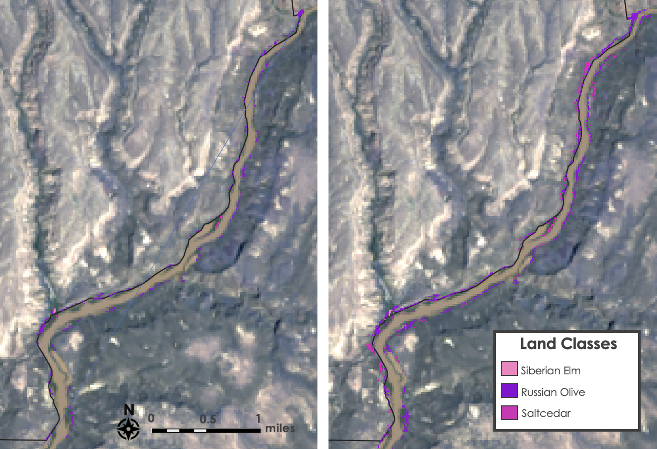

*Figure B1.* The pixels of agreement for each of the invasive species of interests based on classifications derived from all three sensors (left) and only the Sentinel-2 MSI and pansharpened DESIS imagery (right) of BAND

*Figure B2.*  Spectral signatures of the 8 land cover classes of interest examined from June 15, 2022 DESIS imagery of BAND

*Figure B3.*  River transect graphs displaying the change in saltcedar coverage at half-mile intervals along both sides of the portion of the Rio Grande following BAND’s border

*Figure B4.*  River transect graphs displaying the change in Siberian elm coverage at half-mile intervals along both sides of the portion of the Rio Grande following BAND’s border

Appendix C: Classification Uncertainty Analysis

Table C1.

*Confusion matrix for random forest supervised classification trained on June 15, 2022 Landsat 8 OLI imagery*

|  |  |  |  |  |  |  |  |  |  |  |
| --- | --- | --- | --- | --- | --- | --- | --- | --- | --- | --- |
|  | | **Testing points** | | | | | | | | |
| Water | Bare Soil | Grass/  Shrubs | Russian olive | Salt cedar | Siberian elm | Native riparian | Cotton-wood | Total |
| **Prediction** | Water | 16 | 0 | 0 | 2 | 0 | 0 | 3 | 0 | 21 |
| Bare Soil | 0 | 15 | 3 | 0 | 0 | 0 | 0 | 0 | 18 |
| Grass/  Shrubs | 0 | 2 | 11 | 0 | 0 | 0 | 1 | 3 | 17 |
| Russian olive | 0 | 0 | 0 | 10 | 1 | 0 | 1 | 11 | 23 |
| Salt cedar | 2 | 0 | 5 | 4 | 1 | 0 | 3 | 2 | 17 |
| Siberian elm | 0 | 0 | 0 | 0 | 0 | 2 | 0 | 0 | 2 |
| Native riparian | 2 | 0 | 4 | 5 | 2 | 1 | 7 | 2 | 23 |
| Cotton-wood | 0 | 0 | 0 | 7 | 1 | 1 | 1 | 13 | 23 |
| Total | 20 | 17 | 23 | 28 | 5 | 4 | 16 | 31 | 144 |

Table C2.

*Confusion matrix for random forest supervised classification trained on June 15, 2022 Sentinel-2 MSI imagery*

|  |  |  |  |  |  |  |  |  |  |  |
| --- | --- | --- | --- | --- | --- | --- | --- | --- | --- | --- |
|  | | **Testing points** | | | | | | | | |
| **Water** | **Bare soil** | **Grass/ Shrubs** | **Russian olive** | **Saltcedar** | **Siberian elm** | **Native riparian** | **Cotton-wood** | **Total** |
| **Prediction** | **Water** | 20 | 1 | 0 | 0 | 0 | 0 | 0 | 0 | 21 |
| **Bare Soil** | 0 | 17 | 1 | 0 | 0 | 0 | 0 | 0 | 18 |
| **Grass/Shrubs** | 0 | 2 | 12 | 0 | 0 | 1 | 0 | 2 | 17 |
| **Russian olive** | 0 | 0 | 0 | 14 | 0 | 0 | 2 | 7 | 23 |
| **Saltcedar** | 0 | 0 | 5 | 4 | 4 | 0 | 4 | 0 | 17 |
| **Siberian elm** | 0 | 0 | 0 | 0 | 0 | 2 | 0 | 0 | 2 |
| **Native riparian** | 0 | 0 | 1 | 9 | 2 | 0 | 7 | 4 | 23 |
| **Cottonwood** | 0 | 0 | 0 | 3 | 2 | 0 | 2 | 16 | 23 |
| **Total** | 20 | 20 | 19 | 30 | 8 | 3 | 15 | 29 | 144 |

Table C3.

*Confusion matrix for supervised classification derived from 5 PCA band pansharpened June 15, 2022 DESIS imagery*

|  |  |  |  |  |  |  |  |  |  |  |
| --- | --- | --- | --- | --- | --- | --- | --- | --- | --- | --- |
|  | | **Testing points** | | | | | | | | |
| **Water** | **Bare soil** | **Grass/Shrubs** | **Russian olive** | **Saltcedar** | **Siberian elm** | **Native riparian** | **Cottonwood** | **Total** |
| **Prediction** | **Water** | 12 | 0 | 0 | 0 | 0 | 0 | 0 | 0 | 12 |
| **Bare soil** | 0 | 14 | 0 | 0 | 0 | 0 | 0 | 0 | 14 |
| **Grass/ Shrubs** | 0 | 0 | 13 | 0 | 0 | 0 | 0 | 0 | 13 |
| **Russian olive** | 0 | 0 | 0 | 17 | 0 | 0 | 0 | 0 | 17 |
| **Saltcedar** | 0 | 0 | 0 | 0 | 9 | 0 | 0 | 0 | 9 |
| **Siberian elm** | 0 | 0 | 0 | 0 | 0 | 3 | 0 | 0 | 3 |
| **Native riparian** | 0 | 0 | 0 | 0 | 0 | 0 | 17 | 0 | 17 |
| **Cottonwood** | 0 | 0 | 0 | 1 | 0 | 1 | 0 | 22 | 24 |
| **Total** | 12 | 14 | 13 | 18 | 9 | 4 | 17 | 22 | 109 |

Table C4.

*Validation Accuracy and Kappa Coefficient for random forest classifications of pansharpened DESIS imagery*

|  |  |  |  |
| --- | --- | --- | --- |
| **Bands** | **Classes** | **Validation Accuracy** | **Kappa Coefficient** |
| 5 PCA Bands | 8 | 98.17% | 0.9785 |
| 5 PCA Bands | 7 | 95.41% | 0.9428 |
| 29 Spectral Bands | 8 | 97.25% | 0.9678 |
| 29 Spectral Bands | 7 | 97.25% | 0.9656 |
| 235 Spectral Bands | 8 | 97.25% | 0.9677 |
| 235 Spectral Bands | 7 | 98.17% | 0.9771 |

Table C5.

*Validation Accuracy and Kappa Coefficient for SAM classifications of DESIS imagery*

|  |  |  |  |
| --- | --- | --- | --- |
| **Spatial Resolution** | **Pansharpening Band** | **Validation Accuracy** | **Kappa Coefficient** |
| 30 meters | N/A | 40.37% | 0.33 |
| 10 meters | Averaged R, G, B, NIR | 44.95% | 0.38 |

Table C6.

*Confusion matrix for spectral angle mapper classification derived from 235-band June 15, 2022 DESIS imagery*

|  |  |  |  |  |  |  |  |  |  |  |
| --- | --- | --- | --- | --- | --- | --- | --- | --- | --- | --- |
|  | | **Testing points** | | | | | | | | |
| **Water** | **Bare soil** | **Grass/Shrubs** | **Russian olive** | **Saltcedar** | **Siberian elm** | **Native riparian** | **Cottonwood** | **Total** |
| **Prediction** | **Water** | 4 | 2 | 1 | 1 | 0 | 2 | 2 | 0 | 12 |
| **Bare** | 0 | 10 | 4 | 0 | 0 | 0 | 0 | 0 | 14 |
| **Grass/**  **Shrubs** | 0 | 2 | 9 | 0 | 1 | 1 | 0 | 0 | 13 |
| **Russian Olive** | 1 | 0 | 1 | 7 | 0 | 3 | 3 | 2 | 17 |
| **Saltcedar** | 3 | 0 | 0 | 0 | 1 | 2 | 2 | 1 | 9 |
| **Siberian Elm** | 0 | 0 | 0 | 0 | 0 | 3 | 0 | 0 | 3 |
| **Native riparian** | 3 | 0 | 1 | 0 | 0 | 7 | 5 | 1 | 17 |
| **Cottonwood** | 2 | 0 | 3 | 2 | 4 | 5 | 3 | 5 | 24 |
| **Total** | 13 | 14 | 19 | 10 | 6 | 23 | 15 | 9 | 109 |

Table C7.

*Confusion matrix for spectral angle mapper classification derived from pansharpened 235-band June 15, 2022 DESIS imagery*

|  |  |  |  |  |  |  |  |  |  |  |
| --- | --- | --- | --- | --- | --- | --- | --- | --- | --- | --- |
|  | | **Testing points** | | | | | | | | |
| **Water** | **Bare**  **soil** | **Grass/Shrubs** | **Russian olive** | **Saltcedar** | **Siberian elm** | **Native riparian** | **Cottonwood** | **Total** |
| **Prediction** | **Water** | 9 | 0 | 1 | 2 | 0 | 0 | 0 | 0 | 12 |
| **Bare**  **soil** | 0 | 11 | 3 | 0 | 0 | 0 | 0 | 0 | 14 |
| **Grass/ Shrubs** | 0 | 2 | 9 | 0 | 0 | 2 | 0 | 0 | 13 |
| **Russian Olive** | 0 | 0 | 2 | 7 | 2 | 4 | 0 | 2 | 17 |
| **Saltcedar** | 1 | 0 | 1 | 1 | 1 | 4 | 0 | 1 | 9 |
| **Siberian Elm** | 0 | 0 | 0 | 0 | 0 | 3 | 0 | 0 | 3 |
| **Native riparian** | 1 | 1 | 2 | 2 | 0 | 5 | 6 | 0 | 17 |
| **Cottonwood** | 0 | 0 | 2 | 5 | 9 | 4 | 1 | 3 | 24 |
| **Total** | 11 | 14 | 20 | 17 | 12 | 22 | 7 | 6 | 109 |